# Generative AI – Intermediate Level

Best practices to develop LLM application from Ingesting, Embedding/Indexing, Prompting, RAG retrieval and Integrating.

* + Performance improvement Training/tuning
  + Can be called Parameter Efficient Tuning -PET

Transformers, Vector Store, Foundational model(**more parameters better the model**), Prompts, Application.

Special focus on natural language processing (NLP), large language models (LLMs), and generative AI2.

## Transformers

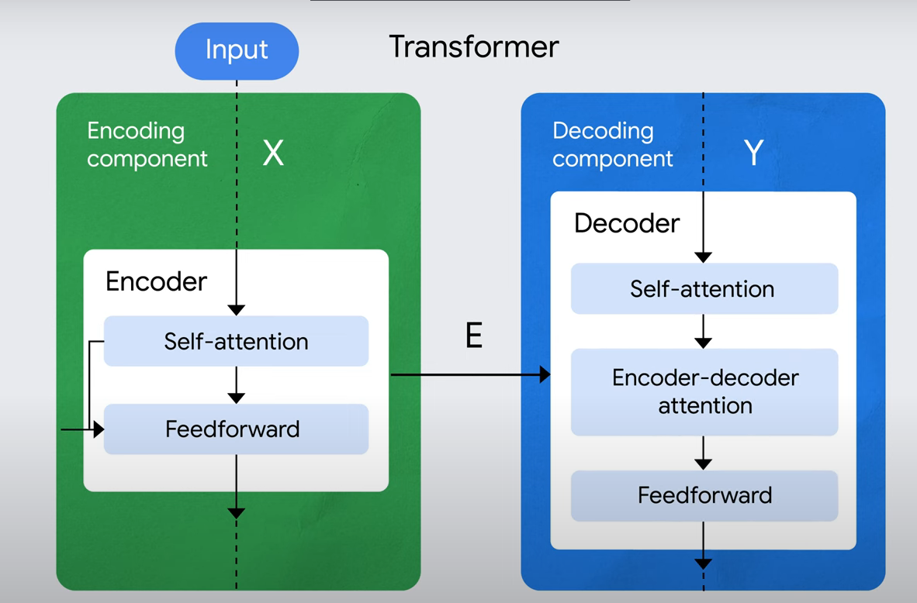

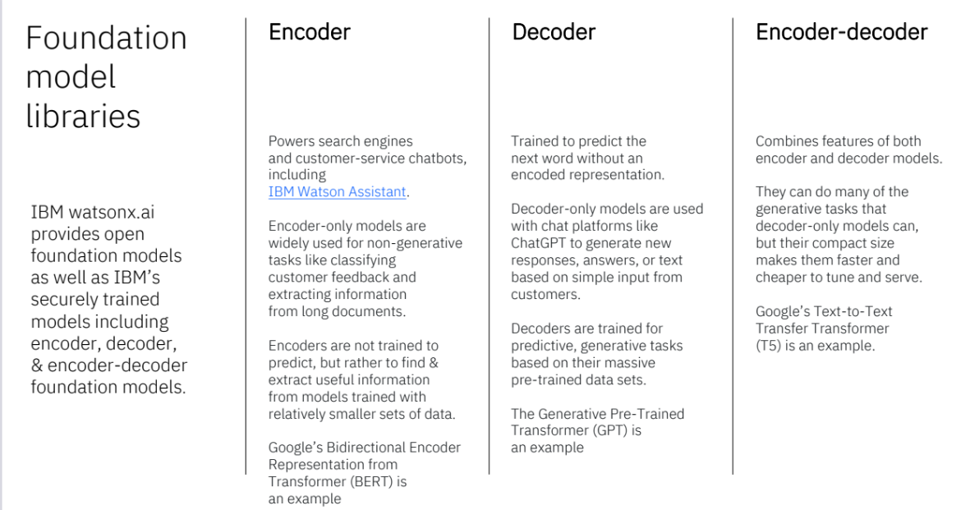

**The main components of the transformer architecture are:**

1. Self-Attention Mechanism-2: This component allows the model to weigh the importance of different words in a sentence by considering the relationships between all words in the input sequence.
2. Encoder and Decoder-2,3,4: The transformer architecture consists of an encoder and a decoder. The encoder processes the input sequence and generates a representation, while the decoder takes that representation and generates the output sequence.
3. Multi-Headed Attention-3: This component allows the model to attend to different parts of the input sequence simultaneously, enabling it to capture different types of information and improve performance.
4. Positional Encoding-1: Since transformers do not have a built-in notion of word order, positional encoding is used to provide information about the position of each word in the input sequence.
5. Feed-Forward Neural Networks -4: These networks are used to transform the representations generated by the self-attention mechanism into a more suitable format for the next layer.

These components work together to enable the transformer architecture to effectively model and generate sequences, making it a powerful tool for tasks like language understanding and generation.

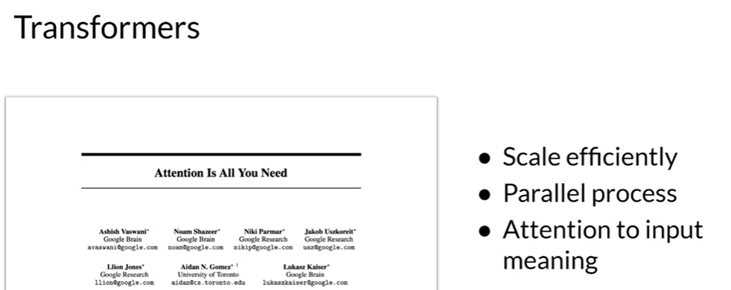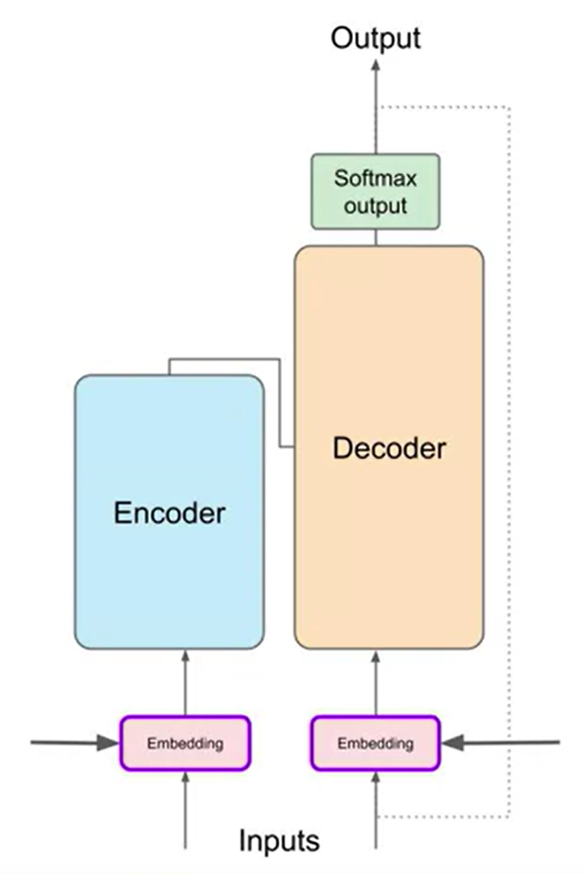

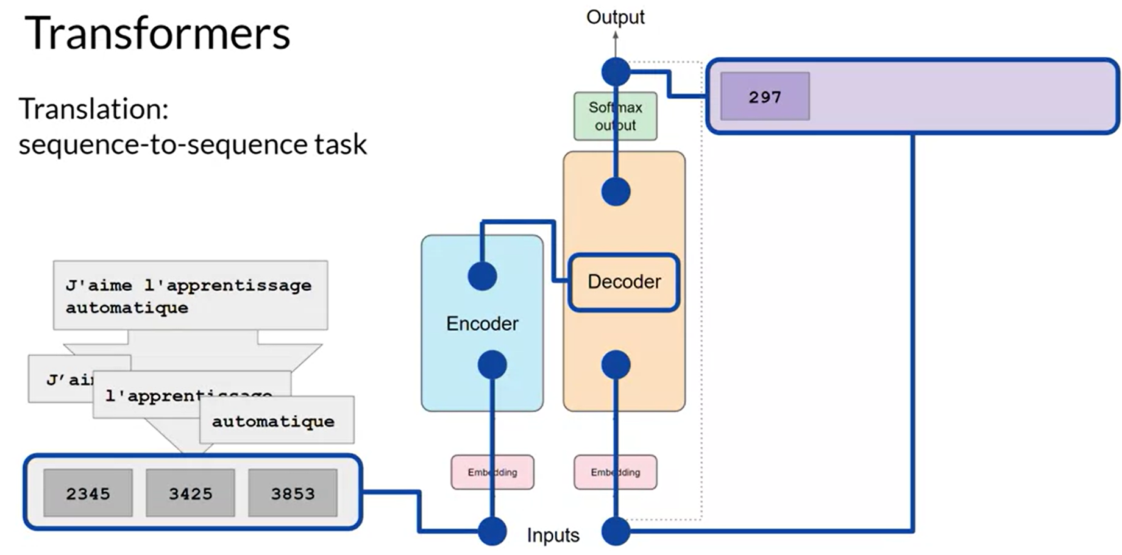

Encoder – Understands the deep meaning of embedding context

Decoder – Generates the new best suitable tokens upon the encoder input tokens

"Attention is All You Need" is a research paper published in 2017 by Google researchers, which introduced the Transformer model, a novel architecture that revolutionized the field of natural language processing (NLP) and became the basis for the LLMs we  now know - such as GPT, PaLM and others. The paper proposes a neural network architecture that replaces traditional recurrent neural networks (RNNs) and convolutional neural networks (CNNs) with an entirely attention-based mechanism.

The Transformer model uses self-attention to compute representations of input sequences, which allows it to capture long-term dependencies and parallelize computation effectively. The authors demonstrate that their model achieves state-of-the-art performance on several machine translation tasks and outperforms previous models that rely on RNNs or CNNs.

The Transformer architecture consists of an encoder and a decoder, each of which is composed of several layers. Each layer consists of two sub-layers: a multi-head self-attention mechanism and a feed-forward neural network. The multi-head self-attention mechanism allows the model to attend to different parts of the input sequence, while the feed-forward network applies a point-wise fully connected layer to each position separately and identically.

The Transformer model also uses residual connections and layer normalization to facilitate training and prevent overfitting. In addition, the authors introduce a positional encoding scheme that encodes the position of each token in the input sequence, enabling the model to capture the order of the sequence without the need for recurrent or convolutional operations.

You can read the Transformers paper [here](https://arxiv.org/abs/1706.03762).

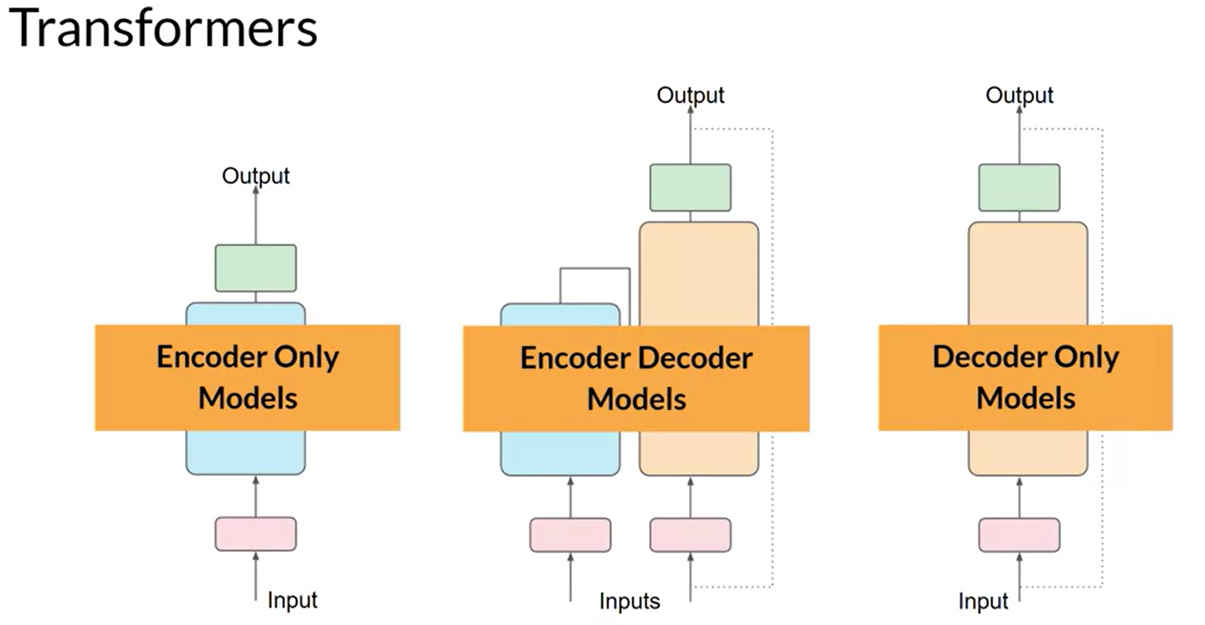

Encoder-only models also work as sequence-to-sequence models, but without further modification, the input sequence and the output sequence or the same length. Their use is less common these days, but by adding additional layers to the architecture, you can train encoder-only models to perform classification tasks such as sentiment analysis, BERT is an example of an encoder-only model.

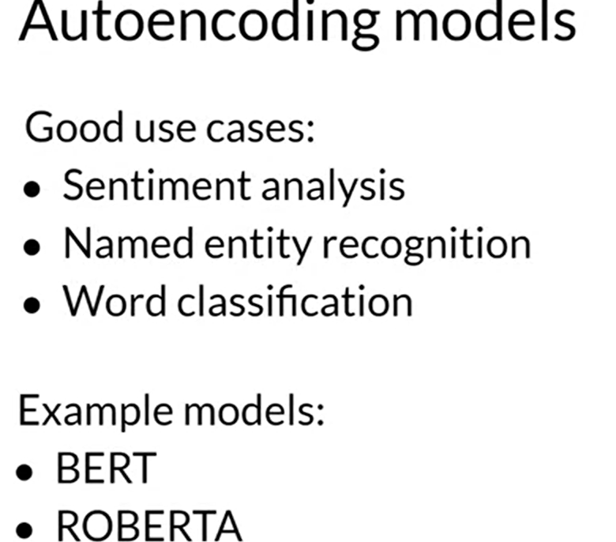

Encoder-decoder models, as you've seen, perform well on sequence-to-sequence tasks such as translation, where the input sequence and the output sequence can be different lengths. You can also scale and train this type of model to perform general text generation tasks. Examples of encoder-decoder models include BART as opposed to BERT and T5, the model that you'll use in the labs in this course. Also called Autoregressive models

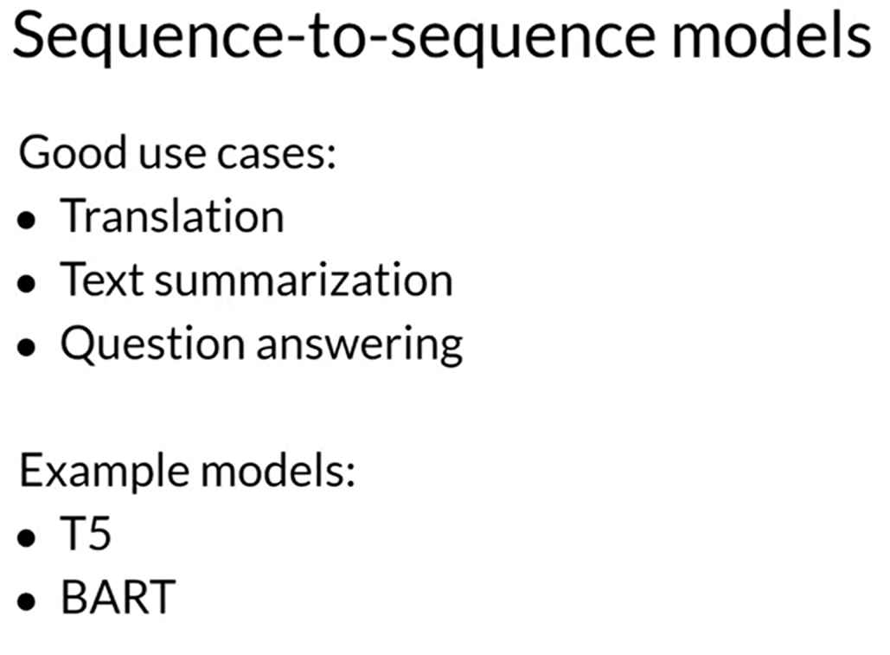

Finally, decoder-only models are some of the most commonly used today. Again, as they have scaled, their capabilities have grown. These models can now generalize to most tasks. Popular decoder-only models include the GPT family of models, BLOOM, Jurassic, LLaMA, and many more.

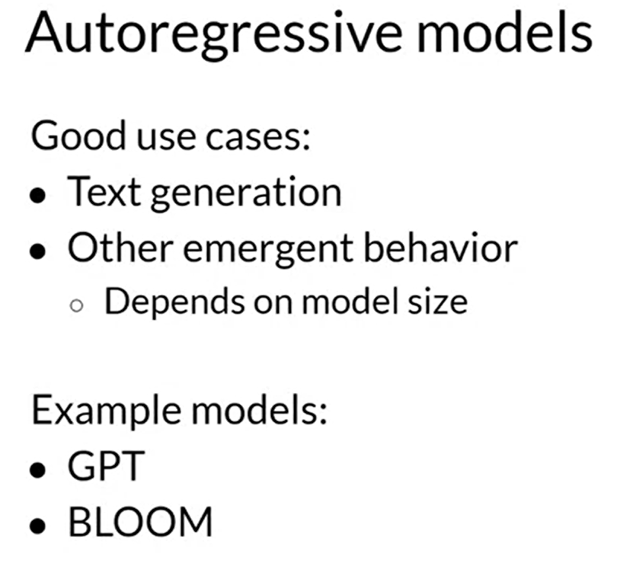

## Prompting And Prompt Engineering:

Prompting is a piece of text generally called input to the LLM to get desired response.

Prompt engineering, improvements to the prompt to take advantage of creativity and to avail full potential of LLM to get desired and accurate response.

**In-context learning (ICL) -zero shot inference:**

Providing the context of extra info to get output

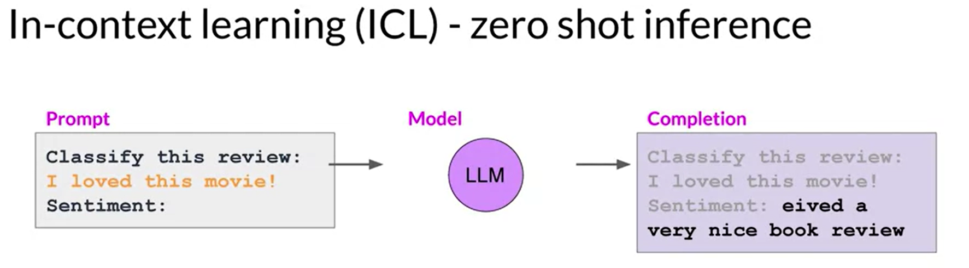

**In-context learning (ICL) -one shot inference:**

Providing the context of extra info and a example to denote a way of understanding to get output

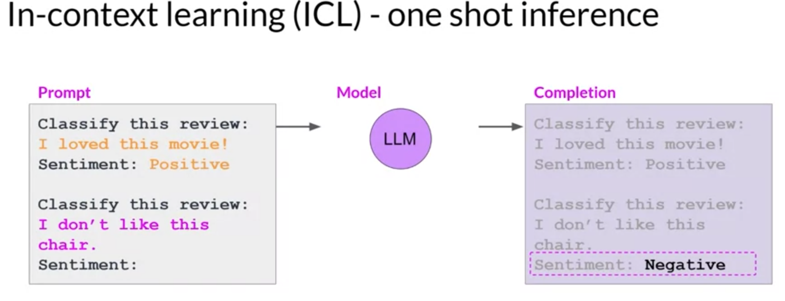

**In-context learning (ICL) -Few shot inference:**

Providing the context of extra info and few examples to tell task to be done to get output.

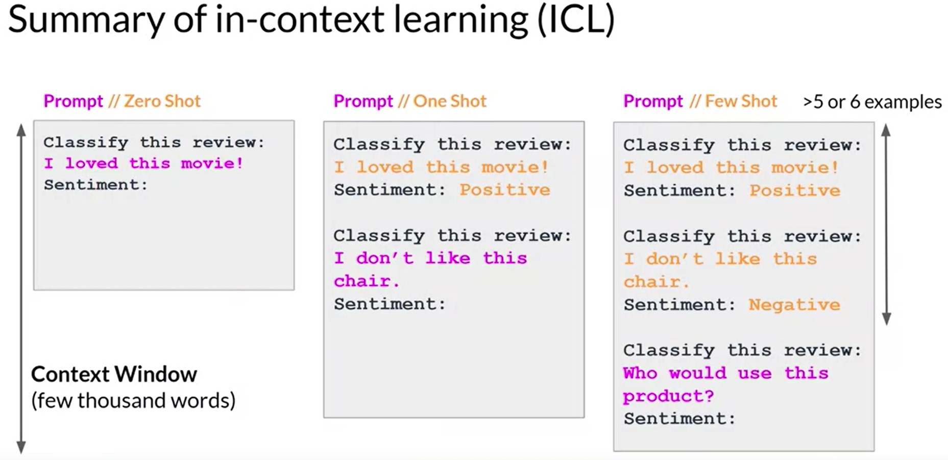

**Generative Configuration-Inference Parameters**

These parameters are applied to softmax output of LLM transformer decoder.

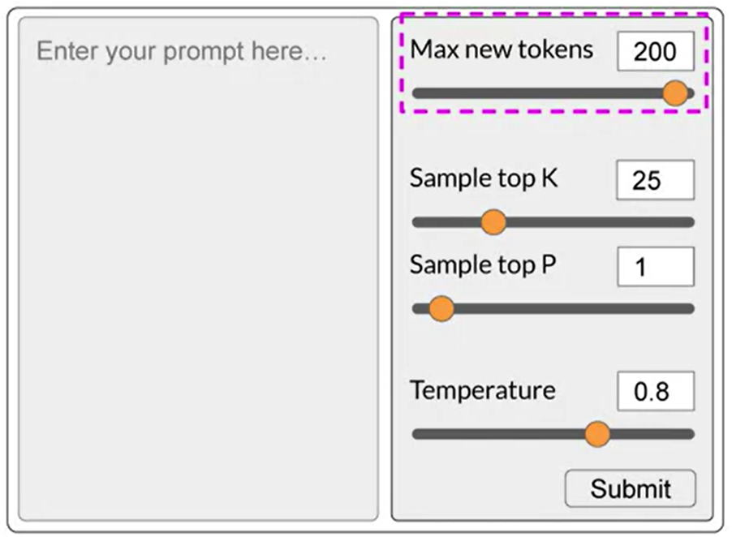

Probability distribution

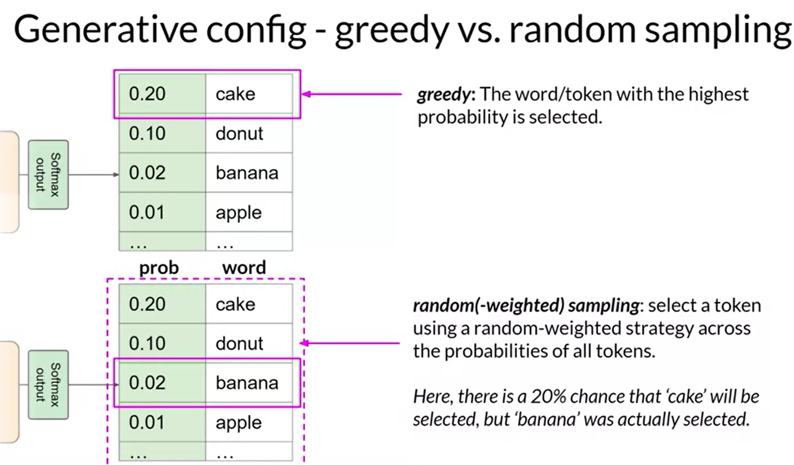

To increase or decrease the random ness of generated tokens , temperature parameter is used.



***LLM use cases and tasks:***

* + Input ()and output tokens are limited
* Text clarification
* Text Extraction
* Text summarization
* Context Q&A -information retrieval
* Translation
* Essay writing
* Invoke API’s and actions

Large Language Models (LLMs) have limitations on the number of tokens they can process effectively. This is because they need to analyze the entire sequence of tokens (words or sub-words) to understand the context and generate meaningful responses. Exceeding the token limit can lead to:

* **Reduced Accuracy:** The LLM might not be able to consider all the information you provide, leading to inaccurate or nonsensical outputs.
* **Increased Processing Time:** Processing a large number of tokens takes more time and resources, potentially causing delays in response generation.
* **Model Instability:** In extreme cases, exceeding the limit might crash the LLM or lead to unexpected behavior.

**Here's a breakdown of token limits and some approaches to deal with them:**

**1. Understanding Token Limits:**

* LLM providers typically don't publicly disclose exact token limits, but they might mention general ranges (e.g., thousands of tokens).
* The limit can vary depending on the specific LLM model and the task at hand.

**2. Techniques to Reduce Token Input:**

* **Truncation:** Trim the beginning or end of your input text while preserving the most important information. However, be cautious not to lose crucial context.
* **Summarization:** Use external tools or techniques to summarize a long document or extract key points before feeding it to the LLM.
* **Chunking:** Break down your input into smaller chunks and process them sequentially. This can be useful for very long tasks like machine translation of entire books.
* **Fine-tuning:** If you have a specific use case with consistently long inputs, consider fine-tuning an LLM to be more efficient with your type of data. This is an advanced technique requiring expertise and resources.

**Additional Tips:**

* **Identify Core Information:** Focus on providing the most relevant and essential information to the LLM for the specific task you want it to perform.
* **Experiment with Input Length:** Gradually increase the input size and observe the LLM's performance to find a sweet spot between detail and efficiency.
* **Consider Alternative Approaches:** Depending on your task, there might be other AI models or techniques better suited for handling large amounts of data.

By being mindful of token limits and utilizing these techniques, you can ensure that your LLM interactions are effective and avoid potential issues caused by exceeding the input capacity.

## Fine Tuning, Prompt Tuning and Prompt Engineering

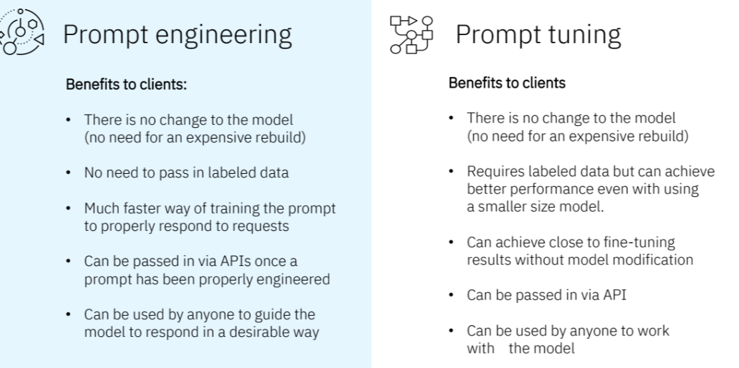

**1. Fine-Tuning:**

* **Involves:** Extensive retraining of the LLM on a large dataset specific to the desired task.
* **Customization Level:** High. The model learns the task-specific patterns and relationships within the dataset.
* **Effort:** High. Requires significant data collection, preparation, and potentially long training times.
* **Resource Requirements:** High. Needs substantial computational resources for training.
* **Control:** High. You have control over the data used for training, influencing the model's behavior.

**2. Prompt Tuning:**

* **Involves:** Adjusting a small set of learnable parameters (often called "soft prompts") appended to the input prompt.
* **Customization Level:** Moderate. Guides the model towards the desired task by influencing its attention mechanism.
* **Effort:** Moderate. Requires knowledge of prompt engineering techniques but less data and training compared to fine-tuning.
* **Resource Requirements:** Moderate. Less computational power needed compared to fine-tuning.
* **Control:** Moderate. You control the prompt and its parameters, but not directly how the model learns the task.

**3. Prompt Engineering:**

* **Involves:** Crafting effective prompts that guide the LLM towards the desired output using its existing knowledge.
* **Customization Level:** Low to Moderate. Relies on the model's pre-trained abilities but can be tailored for specific tasks.
* **Effort:** Low. Requires understanding of the model's capabilities and the task at hand to design effective prompts.
* **Resource Requirements:** Low. No additional training involved, just using the pre-trained model.
* **Control:** Low. You control the prompt design, but the model interprets it based on its existing knowledge.

## Generative AI Project Lifecycle

Pre train is complex and time taking process

Legacy neural network – Recurrent Neural Network

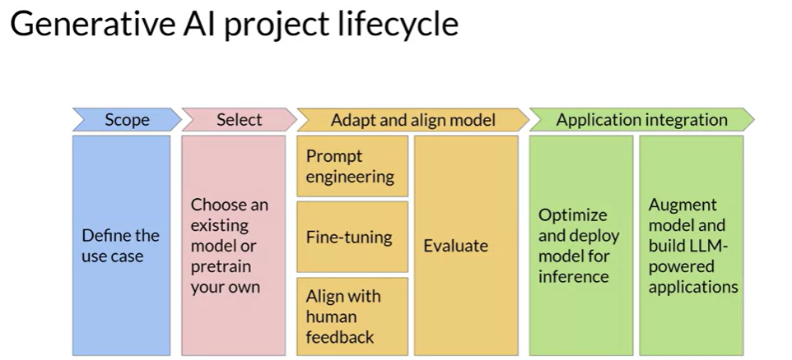

Pretrained LLM – foundational model

Custom LLM – Train your own model

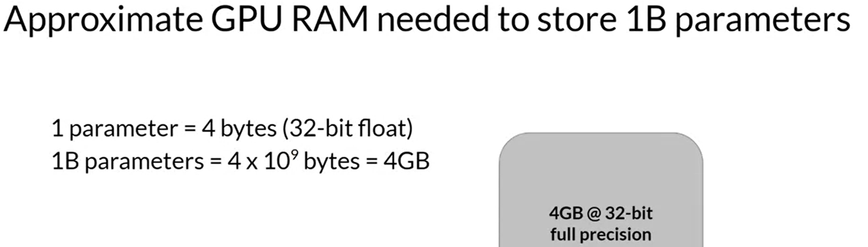

Quantization is method used to reduce to memory required to train a model on dataset.FP16 vs FP32-bit

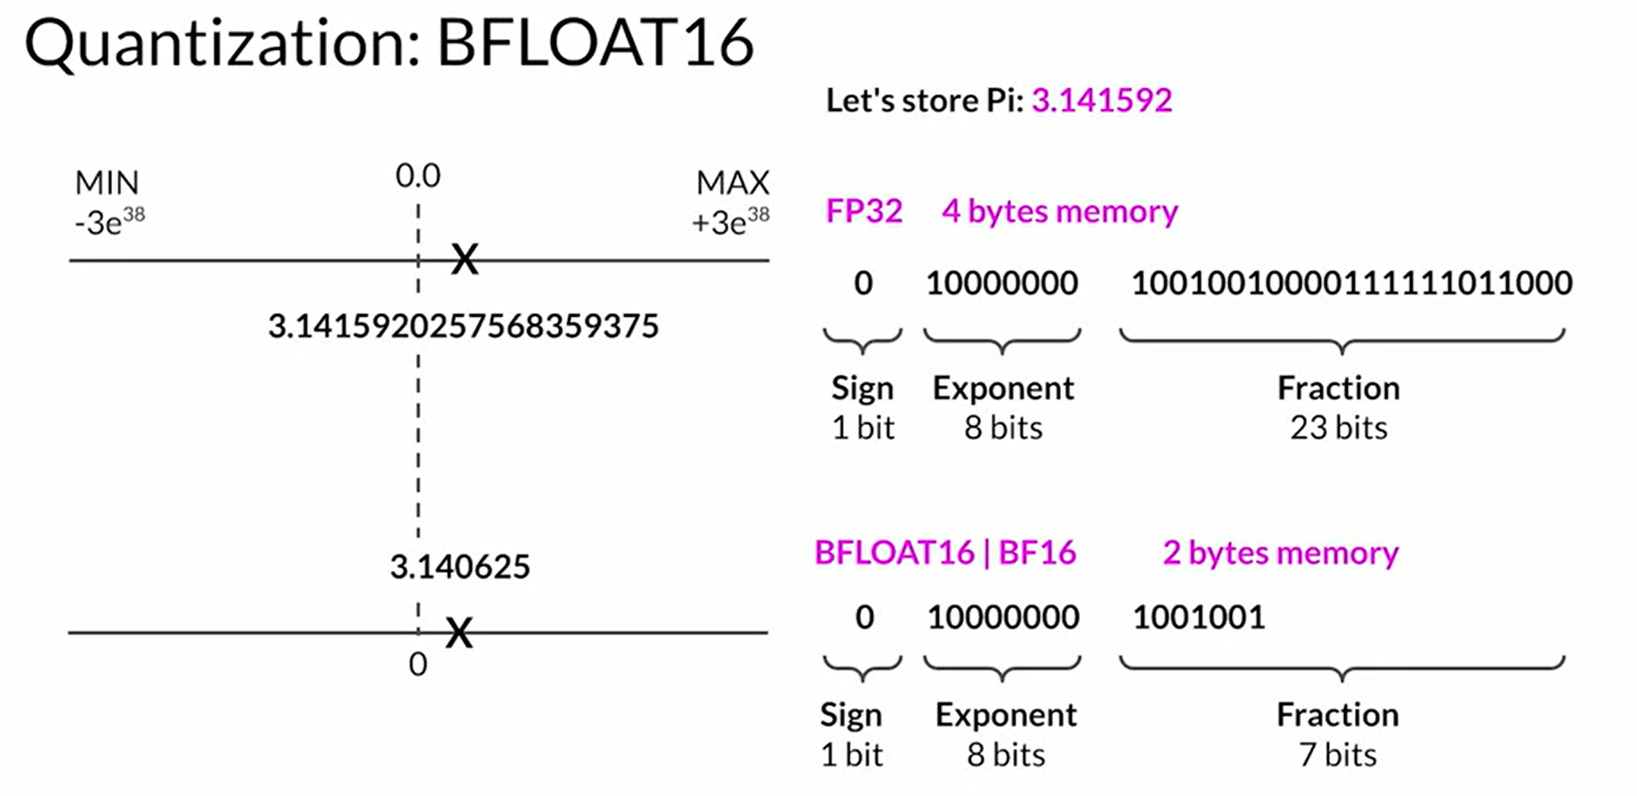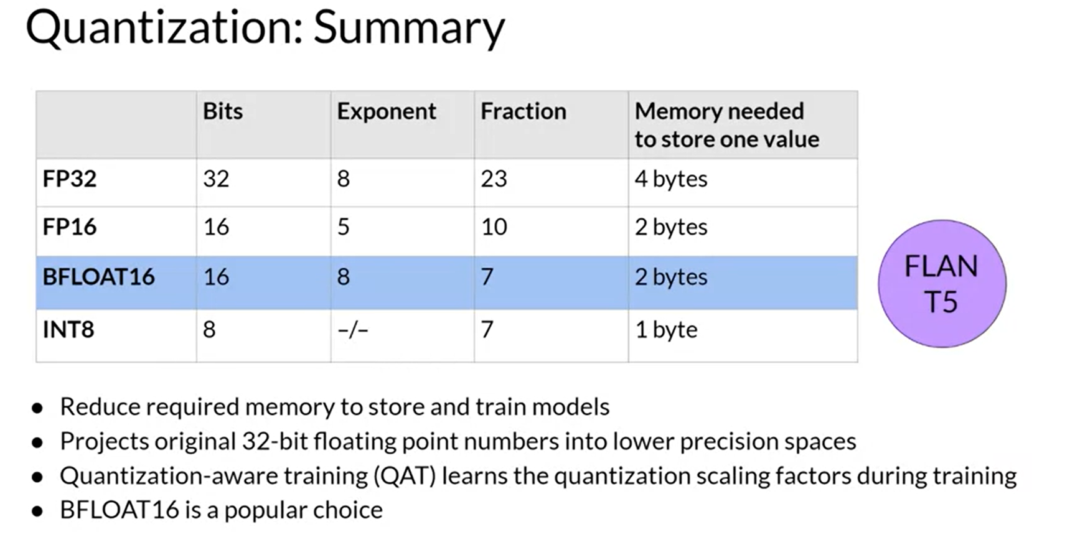

**Efficient Multi- GPU Compute Strategies:**

When to use distribute compute to train LLM?

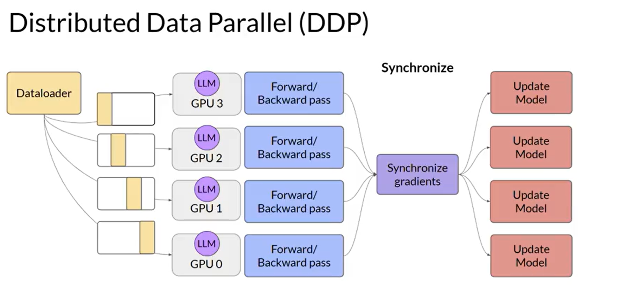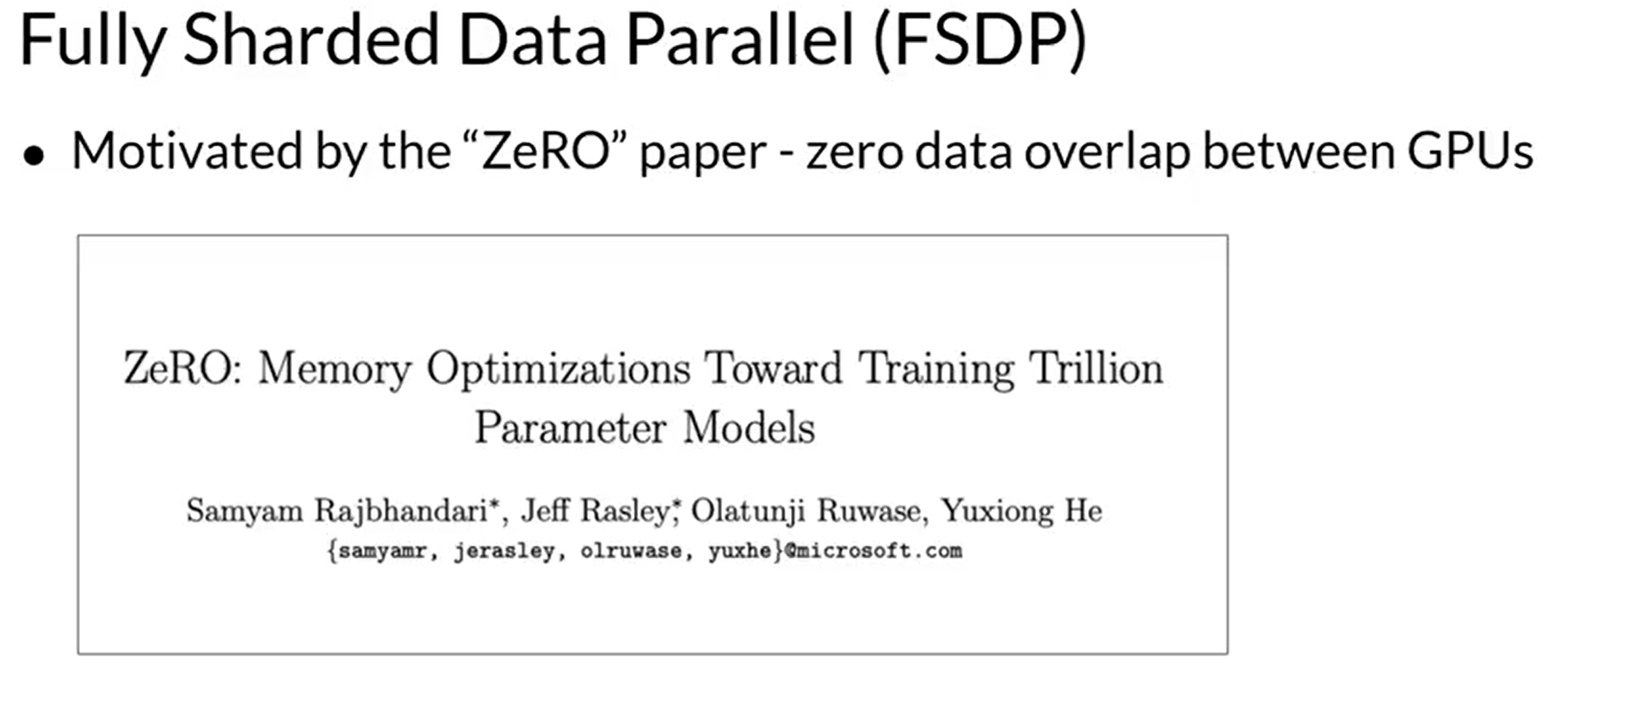

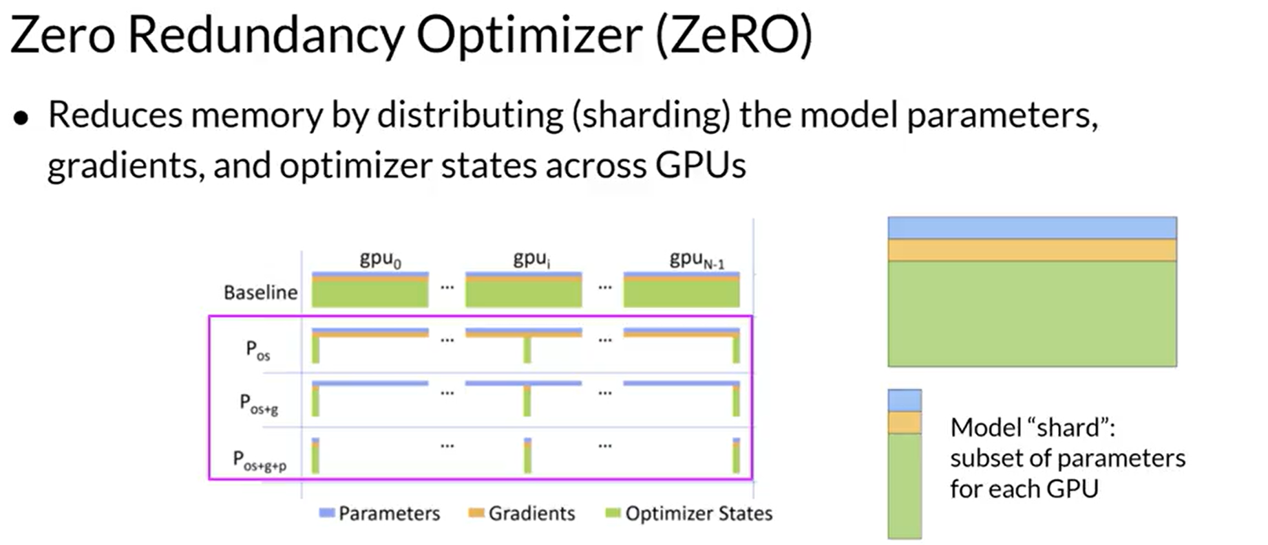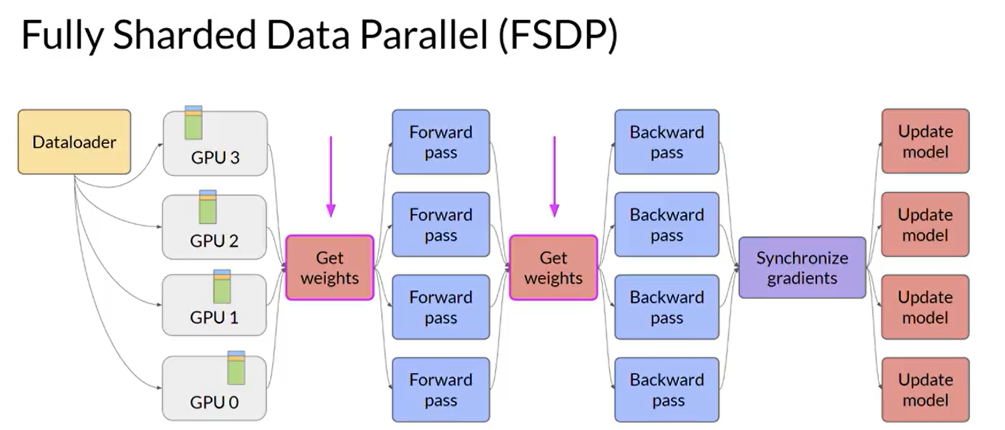

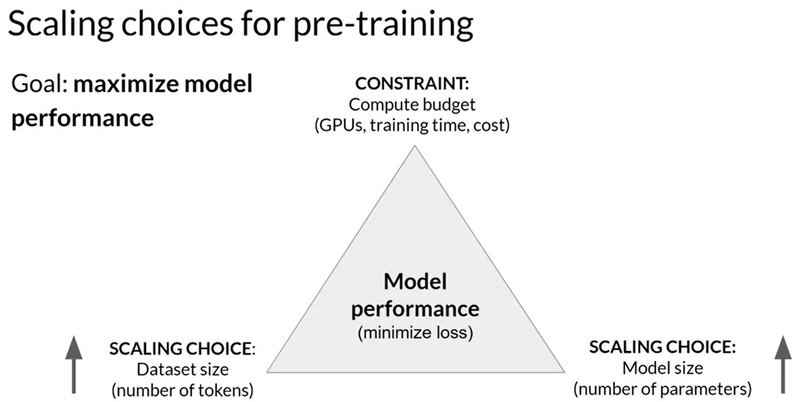

Question 1

Interacting with Large Language Models (LLMs) differs from traditional machine learning models. Working with LLMs involves natural language input, known as a prompt, resulting in output from the Large Language Model, known as the completion.

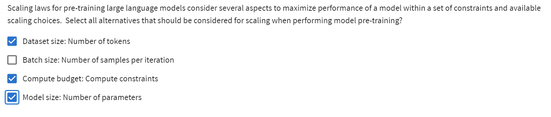

**Generative AI Lifecycle**

* [**Generative AI on AWS: Building Context-Aware, Multimodal Reasoning Applications**](https://www.amazon.com/Generative-AI-AWS-Multimodal-Applications/dp/1098159225/) - This O'Reilly book dives deep into all phases of the generative AI lifecycle including model selection, fine-tuning, adapting, evaluation, deployment, and runtime optimizations.

**Transformer Architecture**

* [**Attention is All You Need**](https://arxiv.org/pdf/1706.03762) - This paper introduced the Transformer architecture, with the core “self-attention” mechanism. This article was the foundation for LLMs.
* [**BLOOM: BigScience 176B Model**](https://arxiv.org/abs/2211.05100) - BLOOM is a open-source LLM with 176B parameters trained in an open and transparent way. In this paper, the authors present a detailed discussion of the dataset and process used to train the model. You can also see a high-level overview of the model [here](https://bigscience.notion.site/BLOOM-BigScience-176B-Model-ad073ca07cdf479398d5f95d88e218c4).
* [**Vector Space Models**](https://www.coursera.org/learn/classification-vector-spaces-in-nlp/home/week/3) - Series of lessons from DeepLearning.AI's Natural Language Processing specialization discussing the basics of vector space models and their use in language modeling.

**Pre-training and scaling laws**

* [**Scaling Laws for Neural Language Models**](https://arxiv.org/abs/2001.08361)- empirical study by researchers at OpenAI exploring the scaling laws for large language models.

**Model architectures and pre-training objectives**

* [**What Language Model Architecture and Pretraining Objective Work Best for Zero-Shot Generalization?**](https://arxiv.org/pdf/2204.05832.pdf) - The paper examines modeling choices in large pre-trained language models and identifies the optimal approach for zero-shot generalization.
* [**HuggingFace Tasks**](https://huggingface.co/tasks) **and** [**Model Hub**](https://huggingface.co/models) - Collection of resources to tackle varying machine learning tasks using the HuggingFace library.
* [**LLaMA: Open and Efficient Foundation Language Models**](https://arxiv.org/pdf/2302.13971.pdf) - Article from Meta AI proposing Efficient LLMs (their model with 13B parameters outperform GPT3 with 175B parameters on most benchmarks)

**Scaling laws and compute-optimal models**

* [**Language Models are Few-Shot Learners**](https://arxiv.org/pdf/2005.14165.pdf)-This paper investigates the potential of few-shot learning in Large Language Models.
* [**Training Compute-Optimal Large Language Models**](https://arxiv.org/pdf/2203.15556.pdf)- Study from DeepMind to evaluate the optimal model size and number of tokens for training LLMs. Also known as “Chinchilla Paper”.
* [**BloombergGPT: A Large Language Model for Finance**](https://arxiv.org/pdf/2303.17564.pdf) - LLM trained specifically for the finance domain, a good example that tried to follow chinchilla laws.

­­­Instruction Fine Tuning:

Improved Performance Model

Instructions – classify, summarize, translate

Instruction must be clear and define a the requirement,

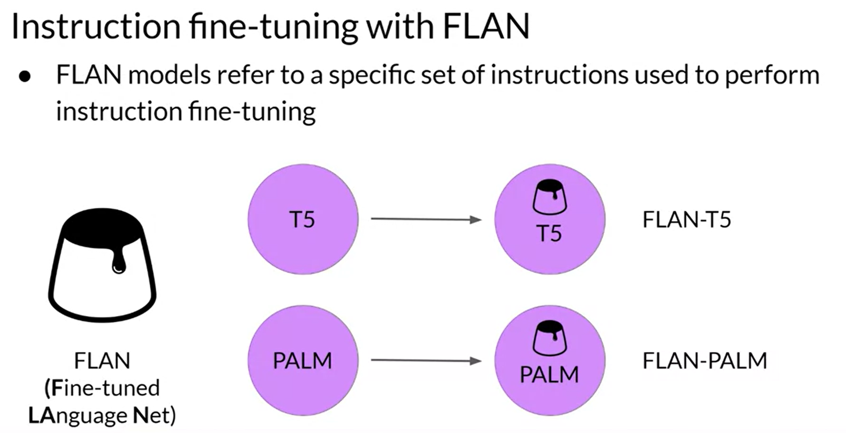

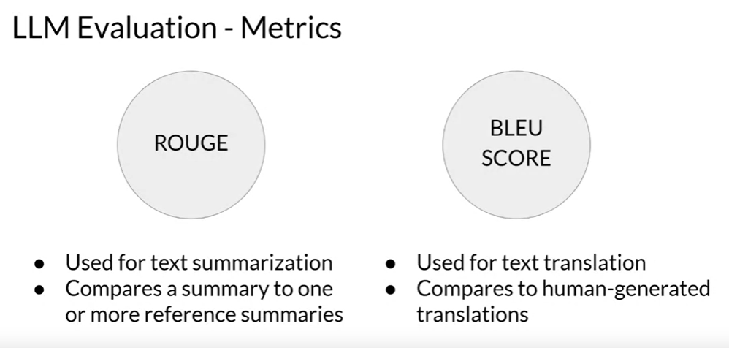

## Parameter Efficient Fine Tuning:

Updates the small subset foundational model

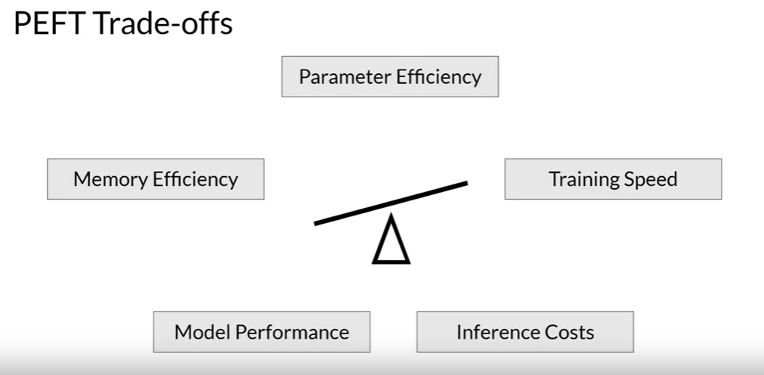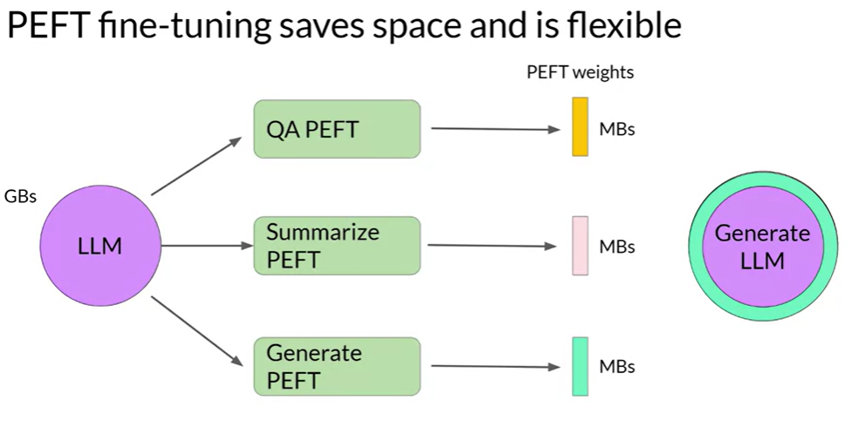

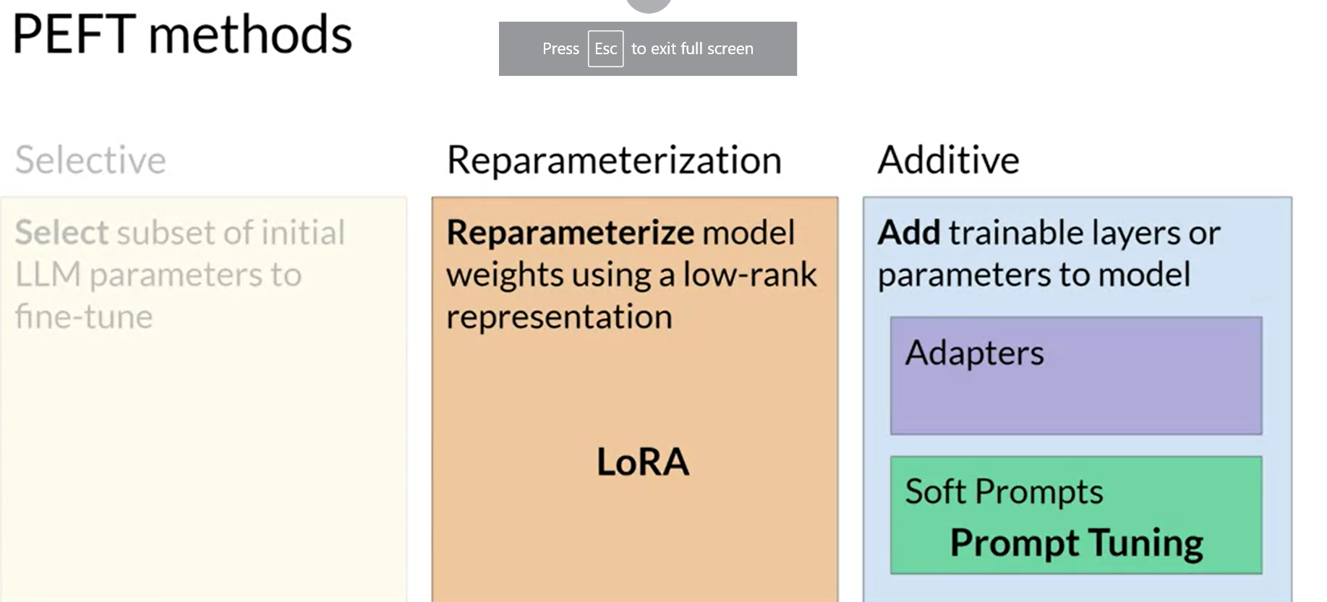

Let's take a look at the three main classes of PEFT methods. **Selective** methods are those that fine-tune only a subset of the original LLM parameters. There are several approaches that you can take to identify which parameters you want to update. You have the option to train only certain components of the model or specific layers, or even individual parameter types. Researchers have found that the performance of these methods is mixed and there are significant trade-offs between parameter efficiency and compute efficiency. We won't focus on them in this course. \**Reparameterization** methods also work with the original LLM parameters, but reduce the number of parameters to train by creating new low rank transformations of the original network weights. A commonly used technique of this type is LoRA, which we'll explore in detail in the next video. Lastly, **additive methods** carry out fine-tuning by keeping all of the original LLM weights frozen and introducing new trainable components. Here there are two main approaches.

Adapter methods add new trainable layers to the architecture of the model, typically inside the encoder or decoder components after the attention or feed-forward layers. Soft prompt methods, on the other hand, keep the model architecture fixed and frozen, and focus on manipulating the input to achieve better performance. This can be done by adding trainable parameters to the prompt embeddings or keeping the input fixed and retraining the embedding weights. In this lesson, you'll take a look at a specific soft prompts technique called prompt tuning.

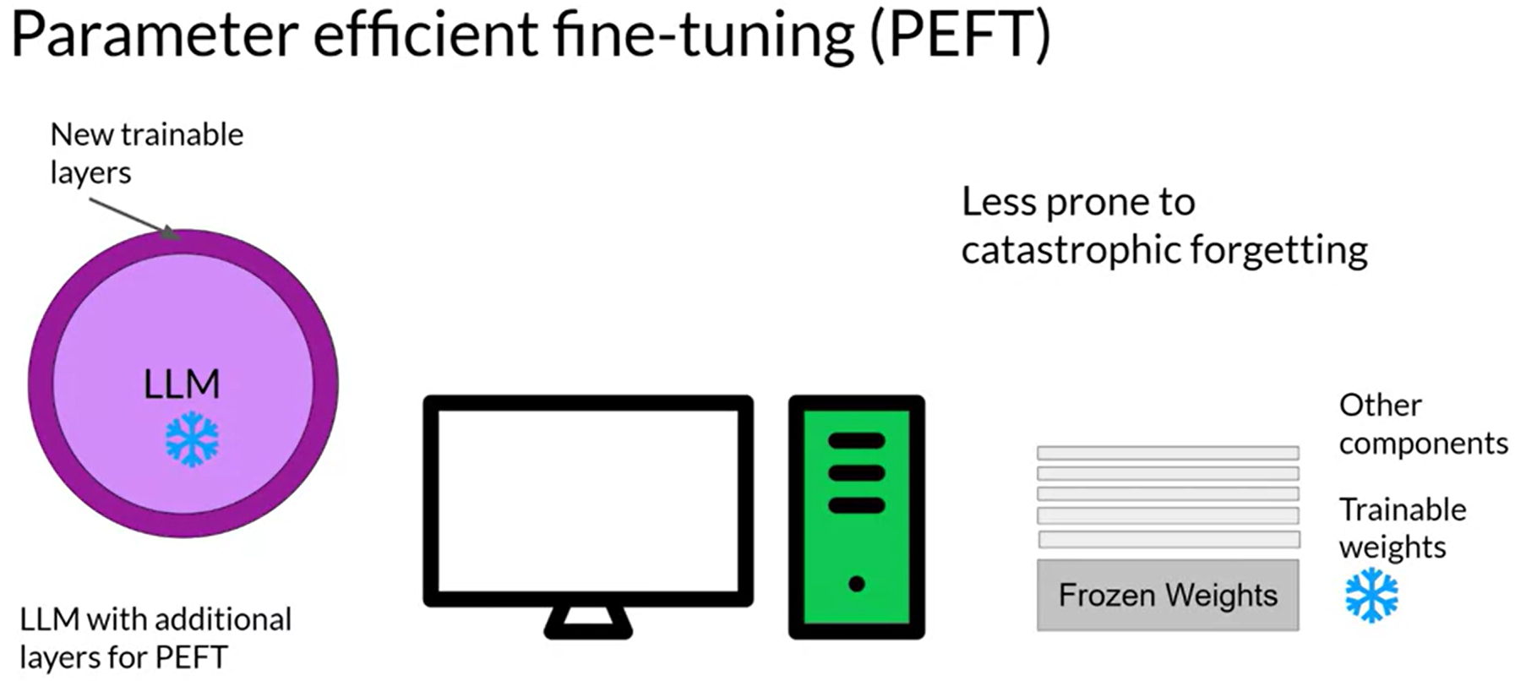

**Full fine-tuning results in a new version of the model for every task you train on. Each of these is the same size as the original model, so it can create an expensive storage problem if you're fine-tuning for multiple tasks.**

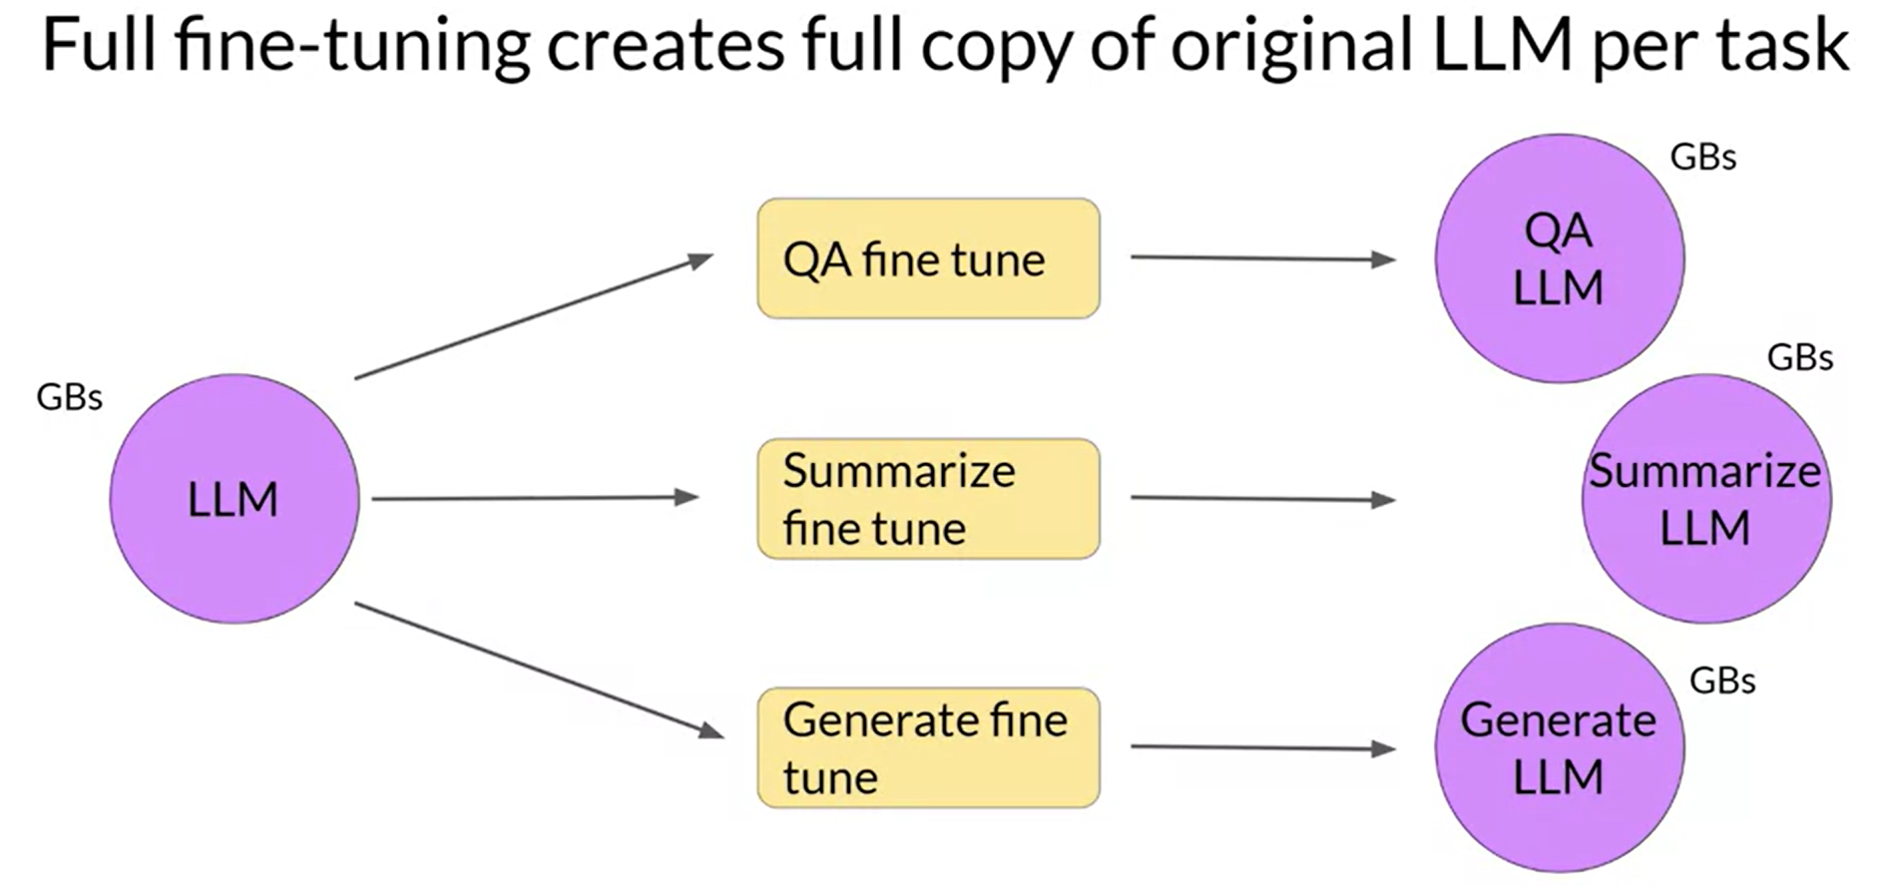

### PEFT technique1 – LoRA

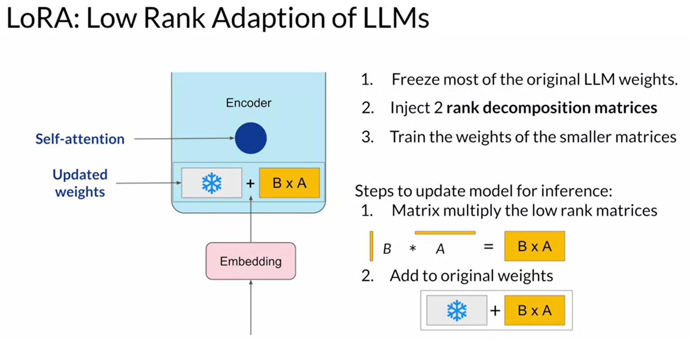

### PEFT technique2 – Soft prompts

Prompt tuning is not a prompt engineering

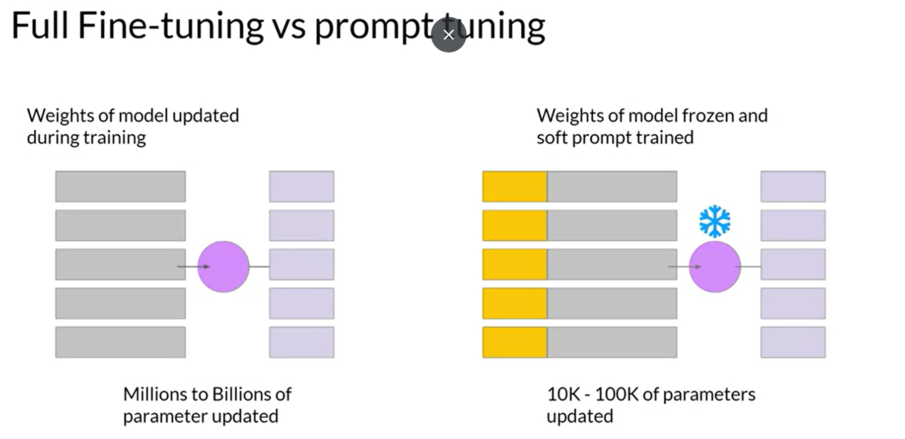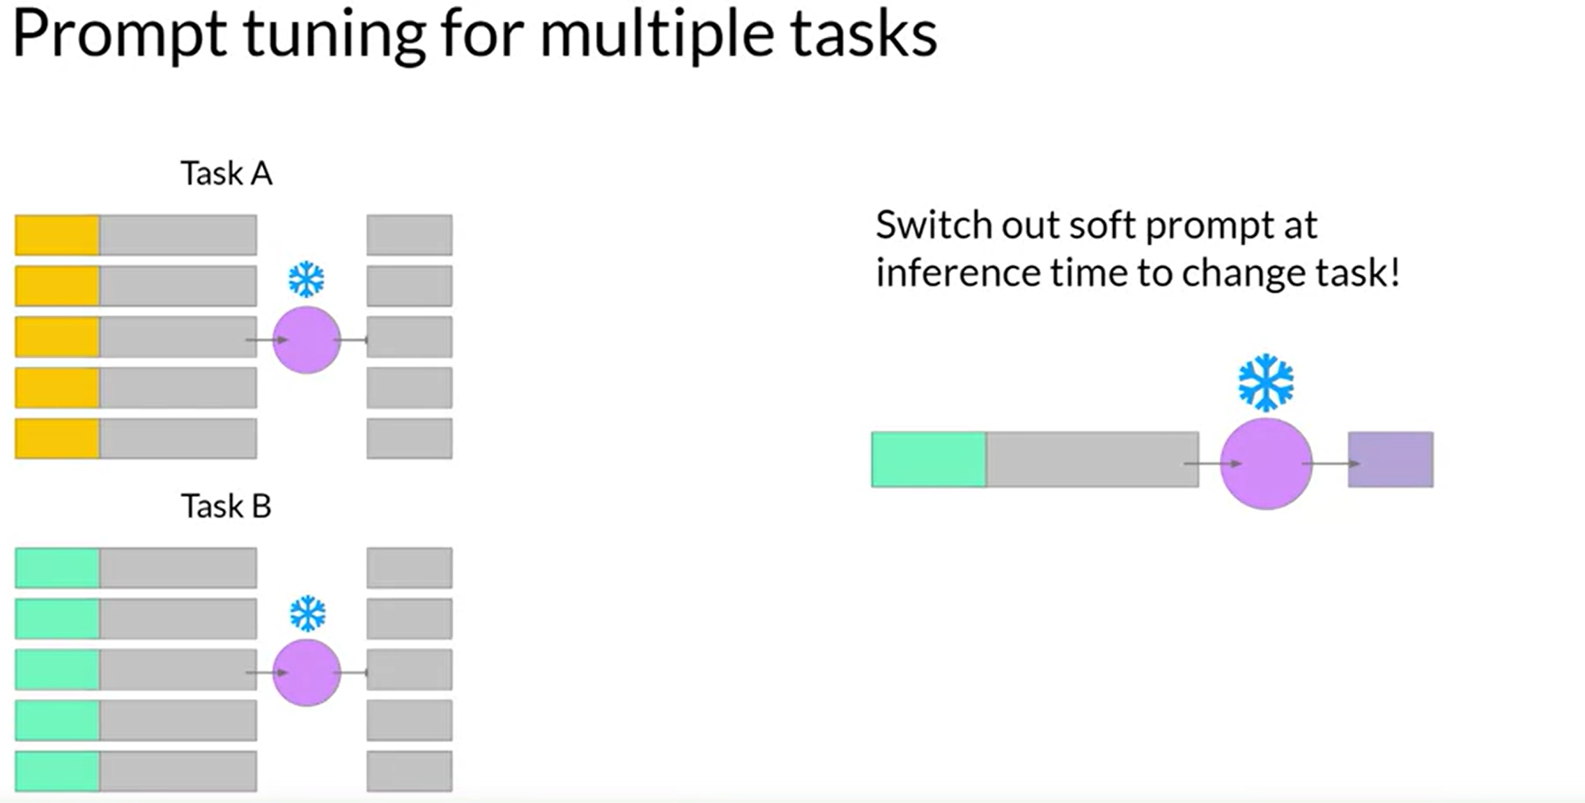

**You can train a different set of soft prompts for each task and then easily swap them out at inference time. You can train a set of soft prompts for one task and a different set for another. To use them for inference, you prepend your input prompt with the learned tokens to switch to another task, you simply change the soft prompt. Soft prompts are very small on disk, so this kind of fine tuning is extremely efficient and flexible.**

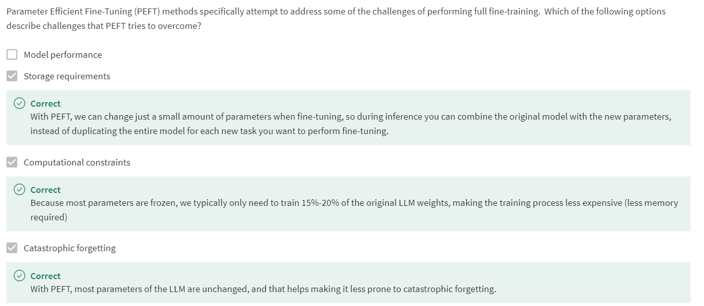

**Generative AI Lifecycle**

* [**Generative AI on AWS: Building Context-Aware, Multimodal Reasoning Applications**](https://www.amazon.com/Generative-AI-AWS-Multimodal-Applications/dp/1098159225/) - This O'Reilly book dives deep into all phases of the generative AI lifecycle including model selection, fine-tuning, adapting, evaluation, deployment, and runtime optimizations.

**Multi-task, instruction fine-tuning**

* [**Scaling Instruction-Finetuned Language Models**](https://arxiv.org/pdf/2210.11416.pdf) - Scaling fine-tuning with a focus on task, model size and chain-of-thought data.
* [**Introducing FLAN: More generalizable Language Models with Instruction Fine-Tuning**](https://ai.googleblog.com/2021/10/introducing-flan-more-generalizable.html) - This blog (and article) explores instruction fine-tuning, which aims to make language models better at performing NLP tasks with zero-shot inference.

**Model Evaluation Metrics**

* [**HELM - Holistic Evaluation of Language Models**](https://crfm.stanford.edu/helm/latest/) - HELM is a living benchmark to evaluate Language Models more transparently.
* [**General Language Understanding Evaluation (GLUE) benchmark**](https://openreview.net/pdf?id=rJ4km2R5t7) - This paper introduces GLUE, a benchmark for evaluating models on diverse natural language understanding (NLU) tasks and emphasizing the importance of improved general NLU systems.
* [**SuperGLUE**](https://super.gluebenchmark.com/) - This paper introduces SuperGLUE, a benchmark designed to evaluate the performance of various NLP models on a range of challenging language understanding tasks.
* [**ROUGE: A Package for Automatic Evaluation of Summaries**](https://aclanthology.org/W04-1013.pdf) - This paper introduces and evaluates four different measures (ROUGE-N, ROUGE-L, ROUGE-W, and ROUGE-S) in the ROUGE summarization evaluation package, which assess the quality of summaries by comparing them to ideal human-generated summaries.
* [**Measuring Massive Multitask Language Understanding (MMLU)**](https://arxiv.org/pdf/2009.03300.pdf) - This paper presents a new test to measure multitask accuracy in text models, highlighting the need for substantial improvements in achieving expert-level accuracy and addressing lopsided performance and low accuracy on socially important subjects.
* [**BigBench-Hard - Beyond the Imitation Game: Quantifying and Extrapolating the Capabilities of Language Models**](https://arxiv.org/pdf/2206.04615.pdf) - The paper introduces BIG-bench, a benchmark for evaluating language models on challenging tasks, providing insights on scale, calibration, and social bias.

**Parameter- efficient fine tuning (PEFT)**

* [**Scaling Down to Scale Up: A Guide to Parameter-Efficient Fine-Tuning**](https://arxiv.org/pdf/2303.15647.pdf) - This paper provides a systematic overview of Parameter-Efficient Fine-tuning (PEFT) Methods in all three categories discussed in the lecture videos.
* [**On the Effectiveness of Parameter-Efficient Fine-Tuning**](https://arxiv.org/pdf/2211.15583.pdf) - The paper analyzes sparse fine-tuning methods for pre-trained models in NLP.

**LoRA**

* [**LoRA Low-Rank Adaptation of Large Language Models**](https://arxiv.org/pdf/2106.09685.pdf)- This paper proposes a parameter-efficient fine-tuning method that makes use of low-rank decomposition matrices to reduce the number of trainable parameters needed for fine-tuning language models.
* [**QLoRA: Efficient Finetuning of Quantized LLMs**](https://arxiv.org/pdf/2305.14314.pdf) - This paper introduces an efficient method for fine-tuning large language models on a single GPU, based on quantization, achieving impressive results on benchmark tests.

**Prompt tuning with soft prompts**

* [**The Power of Scale for Parameter-Efficient Prompt Tuning**](https://arxiv.org/pdf/2104.08691.pdf) - The paper explores "prompt tuning," a method for conditioning language models with learned soft prompts, achieving competitive performance compared to full fine-tuning and enabling model reuse for many tasks.

## **Reinforcement learning and LLM-powered applications:**

RLHF - Reinforcement learning from human feedback

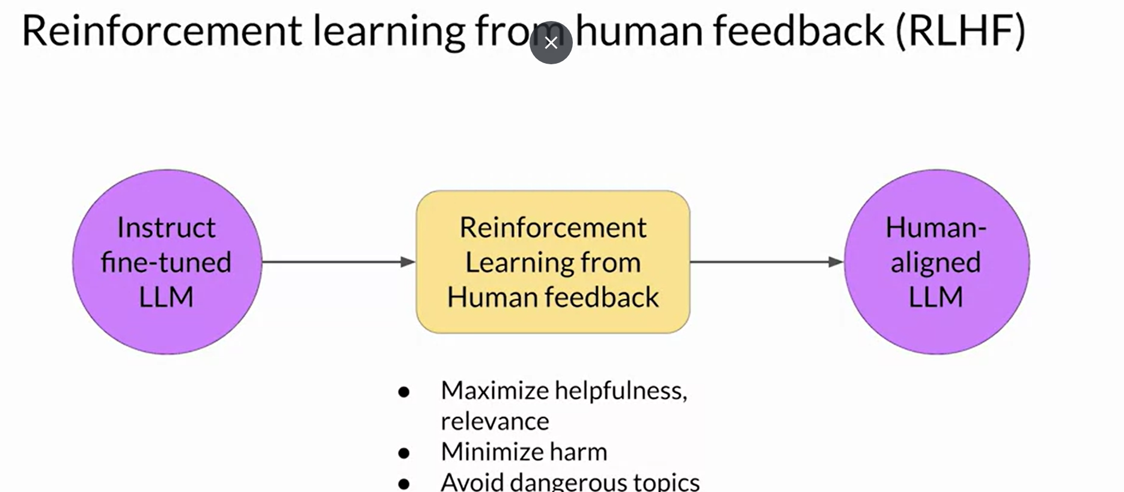

**Direct Preference Optimization: Your Language Model is Secretly a Reward Model**

[Rafael Rafailov](https://arxiv.org/search/cs?searchtype=author&query=Rafailov,+R), [Archit Sharma](https://arxiv.org/search/cs?searchtype=author&query=Sharma,+A), [Eric Mitchell](https://arxiv.org/search/cs?searchtype=author&query=Mitchell,+E), [Stefano Ermon](https://arxiv.org/search/cs?searchtype=author&query=Ermon,+S), [Christopher D. Manning](https://arxiv.org/search/cs?searchtype=author&query=Manning,+C+D), [Chelsea Finn](https://arxiv.org/search/cs?searchtype=author&query=Finn,+C)

While large-scale unsupervised language models (LMs) learn broad world knowledge and some reasoning skills, achieving precise control of their behavior is difficult due to the completely unsupervised nature of their training. Existing methods for gaining such steerability collect human labels of the relative quality of model generations and fine-tune the unsupervised LM to align with these preferences, often with reinforcement learning from human feedback (RLHF). However, RLHF is a complex and often unstable procedure, first fitting a reward model that reflects the human preferences, and then fine-tuning the large unsupervised LM using reinforcement learning to maximize this estimated reward without drifting too far from the original model. In this paper we introduce a new parameterization of the reward model in RLHF that enables extraction of the corresponding optimal policy in closed form, allowing us to solve the standard RLHF problem with only a simple classification loss. The resulting algorithm, which we call Direct Preference Optimization (DPO), is stable, performant, and computationally lightweight, eliminating the need for sampling from the LM during fine-tuning or performing significant hyperparameter tuning. Our experiments show that DPO can fine-tune LMs to align with human preferences as well as or better than existing methods. Notably, fine-tuning with DPO exceeds PPO-based RLHF in ability to control sentiment of generations, and matches or improves response quality in summarization and single-turn dialogue while being substantially simpler to implement and train.

## LLM Powered Applications

RAG

Program Aided language models (PAL)

ReAct: Combining reasoning and action

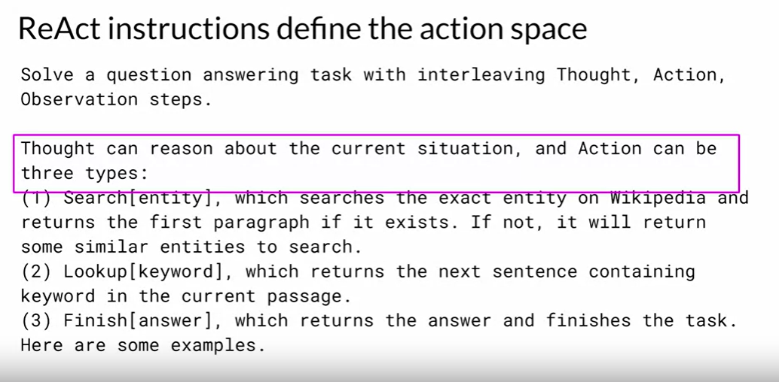

# ReAct: Reasoning and action

[This paper](https://arxiv.org/abs/2210.03629) introduces ReAct, a novel approach that integrates verbal reasoning and interactive decision making in large language models (LLMs). While LLMs have excelled in language understanding and decision making, the combination of reasoning and acting has been neglected. ReAct enables LLMs to generate reasoning traces and task-specific actions, leveraging the synergy between them. The approach demonstrates superior performance over baselines in various tasks, overcoming issues like hallucination and error propagation. ReAct outperforms imitation and reinforcement learning methods in interactive decision making, even with minimal context examples. It not only enhances performance but also improves interpretability, trustworthiness, and diagnosability by allowing humans to distinguish between internal knowledge and external information.

In summary, ReAct bridges the gap between reasoning and acting in LLMs, yielding remarkable results across language reasoning and decision making tasks. By interleaving reasoning traces and actions, ReAct overcomes limitations and outperforms baselines, not only enhancing model performance but also providing interpretability and trustworthiness, empowering users to understand the model's decision-making process.

## **Generative AI Lifecycle**

* [**Generative AI on AWS: Building Context-Aware, Multimodal Reasoning Applications**](https://www.amazon.com/Generative-AI-AWS-Multimodal-Applications/dp/1098159225/) - This O'Reilly book dives deep into all phases of the generative AI lifecycle including model selection, fine-tuning, adapting, evaluation, deployment, and runtime optimizations.

## **Reinforcement Learning from Human-Feedback (RLHF)**

* [**Training language models to follow instructions with human feedback**](https://arxiv.org/pdf/2203.02155.pdf) **-** Paper by OpenAI introducing a human-in-the-loop process to create a model that is better at following instructions (InstructGPT).
* [**Learning to summarize from human feedback**](https://arxiv.org/pdf/2009.01325.pdf) - This paper presents a method for improving language model-generated summaries using a reward-based approach, surpassing human reference summaries.

## **Proximal Policy Optimization (PPO)**

* [**Proximal Policy Optimization Algorithms**](https://arxiv.org/pdf/1707.06347.pdf) - The paper from researchers at OpenAI that first proposed the PPO algorithm. The paper discusses the performance of the algorithm on a number of benchmark tasks including robotic locomotion and game play.
* [**Direct Preference Optimization: Your Language Model is Secretly a Reward Model**](https://arxiv.org/pdf/2305.18290.pdf) - This paper presents a simpler and effective method for precise control of large-scale unsupervised language models by aligning them with human preferences.

## **Scaling human feedback**

* [**Constitutional AI: Harmlessness from AI Feedback**](https://arxiv.org/pdf/2212.08073.pdf)-This paper introduces a method for training a harmless AI assistant without human labels, allowing better control of AI behavior with minimal human input.

## **Advanced Prompting Techniques**

* [**Chain-of-thought Prompting Elicits Reasoning in Large Language Models**](https://arxiv.org/pdf/2201.11903.pdf) - Paper by researchers at Google exploring how chain-of-thought prompting improves the ability of LLMs to perform complex reasoning.
* [**PAL: Program-aided Language Models**](https://arxiv.org/abs/2211.10435) - This paper proposes an approach that uses the LLM to read natural language problems and generate programs as the intermediate reasoning steps.
* [**ReAct: Synergizing Reasoning and Acting in Language Models**](https://arxiv.org/abs/2210.03629) This paper presents an advanced prompting technique that allows an LLM to make decisions about how to interact with external applications.

## **LLM powered application architectures**

* [**LangChain Library (GitHub)**](https://github.com/hwchase17/langchain)- This library is aimed at assisting in the development of those types of applications, such as Question Answering, Chatbots and other Agents. You can read the documentation [here](https://docs.langchain.com/docs/).
* [**Who Owns the Generative AI Platform?**](https://a16z.com/2023/01/19/who-owns-the-generative-ai-platform/)- The article examines the market dynamics and business models of generative AI.

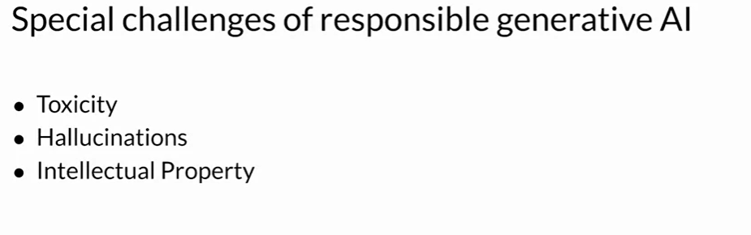

# **Advance Learnings on Langchain**

Best example for Abstraction

Pipenv shell is used to create a virtual environment.

Prompt – a text input to given to a LLM to get desired response

Prompt Template – to create dynamic prompts with input context.

## Chat models:

Chat Models are a core component of LangChain.

A chat model is a language model that uses chat messages as inputs and returns chat messages as outputs (as opposed to using plain text).

LangChain has integrations with many model providers (OpenAI, Cohere, Hugging Face, etc.) and exposes a standard interface to interact with all of these models.

Import the necessary chatmodel of respective AI package and configure with model to use.

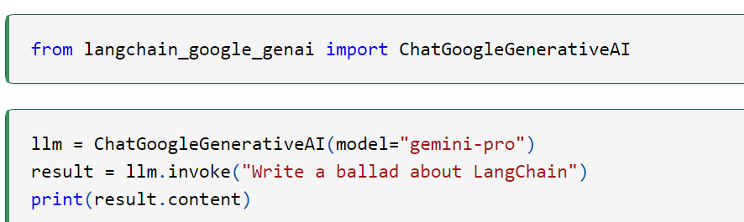

## Chains:

<https://python.langchain.com/docs/modules/chains/>

Chains refer to sequences of calls - whether to an LLM, a tool, or a data preprocessing step.